Dungannon Gospel Hall
Child Protection & Safeguarding Policy (Northern Ireland)
1. Policy Statement
The assembly of Christians meeting at Dungannon Gospel Hall is fully committed to safeguarding and promoting the welfare of all children and young people (under 18) who attend its activities.
We recognise our legal and moral duty of care to protect children from harm and to provide a safe environment in which they can learn, grow, and participate in Christian teaching. The welfare of the child is paramount.
Our Lord Jesus Christ taught that “whosoever shall receive one of such children in my name, receiveth Me” (Mark 9:37). As well as this, the seriousness of stumbling a child is highlighted in Matthew 18:6, Mark 9:42, and Luke 17:2. Our attitude and behaviour towards children is of great importance.
God’s word also calls us to be “blameless” (2 Peter 3:14) and to “walk circumspectly, not as fools, but as wise,” (Ephesians 5:15). It is vital that all that we do is seen to be above reproach and honouring to our Lord Jesus Christ.
This policy applies to:
- All leaders, helpers, and volunteers
- All children attending activities organised by the assembly.
- All activities both on and off church premises, including transport.
2. Legal Framework (Northern Ireland)
This policy is based on current Northern Ireland safeguarding legislation and guidance, including:
- The Children (Northern Ireland) Order 1995 (childprotectionuk.co.uk)
- The Safeguarding Board Act (NI) 2011 (childprotectionuk.co.uk)
- Co-operating to Safeguard Children and Young People in NI (updated 2024) (Department of Health)
- Criminal Law Act (NI) 1967 (duty to report offences) (childprotectionuk.co.uk)
We also follow best practice guidance for faith organisations, which requires safeguarding policies, trained leaders, and clear reporting procedures. (NSPCC Learning)

3. Safeguarding Principles
Dungannon Gospel Hall will:
- Provide a safe, caring, and respectful environment,
- Ensure all children are treated with dignity and fairness,
- Promote the wellbeing and development of every child,
- Take all concerns and disclosures seriously,
- Work in partnership with parents, carers, and statutory authorities,
All children have the right to protection from abuse regardless of background or ability.
4. Roles and Responsibilities
4.1 Designated Safeguarding Lead (DSL)
The assembly will appoint a Designated Safeguarding Lead (and deputy if possible), responsible for:
- Receiving concerns or disclosures
- Liaising with Social Services / PSNI
- Maintaining secure records
- Ensuring policy implementation
Faith organisations are expected to appoint such a lead. (NSPCC Learning)
4.2 Leaders and Volunteers
All workers must:
- Follow this policy and code of conduct,
- Attend safeguarding training (refreshed regularly),
- Report concerns immediately,
- Avoid situations where they are alone with a child,

5. Vetting Potential Volunteers (AccessNI)
Dungannon Gospel Hall will operate safe volunteer appointment procedures, including:
- Only those who are members of the Christian assembly at Dungannon Gospel Hall, will be permitted to be actively involved in the running and organising of activities for children and young people. This will mean they are baptised believers, who will have been interviewed by the elders prior to membership, they will be responsible to the assembly and to the Lord for their behaviour and will be held to the high standards of behaviour which the Bible teaches.
- Meeting with leadership prior to beginning to volunteer, and regularly thereafter.
- Appropriate AccessNI checks for roles involving children,
AccessNI provides criminal record checks to help organisations recruit safely into positions of trust.
Enhanced AccessNI checks will be required where roles meet regulated activity criteria.
No individual may begin unsupervised work with children until checks are completed.
Any invited guests who are not members of the Dungannon assembly will be supervised during any visits.
6. Code of Behaviour (Working Safely with Children)
Leaders must:
- Remember they are representing the Lord in all their actions. What we do is as important as what we say.
- Treat all children equally and respectfully.
- Be a positive role model and provide encouragement and support,
- Maintain appropriate boundaries,
- Avoid favouritism or private contact with individual children,
- Ensure physical contact is appropriate and minimal,
- Avoid being on their phones when supervising children. If an urgent need arises to use their phone, they should ensure that adequate supervision is in place before doing so privately.

Leaders must not:
- Be alone with a child in private,
- Do anything of a personal nature for children that they can do for themselves,
- Engage in abusive, humiliating, sarcastic or inappropriate behaviour,
- Transport a child alone without prior consent and safeguards,
- Tickle, poke, or engage in any rough play,
- Allow children to use inappropriate language unchallenged,
- Allow dangerous behaviour,
- Communicate privately with a child via social media or messaging,
- Take photos or videos of children unless with parental consent.
- Let allegations made by a child go unrecorded.
7. Supervision Ratios
Appropriate adult-to-child ratios will be maintained:
- Under 8s: approx. 1 adult to 6–8 children
- Over 8s: approx. 1 adult to 10–12 children
At least two adults must be present at all times.
8. Transport Policy (Minibus & Private Cars)
Given that transport is part of ministry activities, the following rules apply:
8.1 General
- Written parental consent must be obtained for transport,
- A register of children being transported must be kept,
- At least two adults should be present where possible,
- Seatbelts must be worn at all times,
8.2 Drivers
All drivers must:
- Hold a valid driving licence,
- Be appropriately insured for transporting children,
- Be approved by church leadership,
- Have undergone AccessNI checks where required,

8.3 Minibus Use
- Must comply with NI road safety and licensing laws,
- A responsible adult (not the driver) should supervise children on the bus,
- Everyone on the bus has the right to feel safe, and not to be threatened or abused, either physically or verbally. The bus conductor must always be on the lookout to safeguard the wellbeing of every child. Separation of certain individuals may be necessary to avoid conflict.
- Parents have a right to know that their children are being picked up and returned safely. It is the responsibility of the bus conductor or bus driver to escort children across roads and ensure they don’t run out from behind the bus.
- Children must be brought to their front door and parents must know their child is home.
8.4 Private Cars
- Avoid transporting a child alone; if unavoidable:
- Parent consent required,
- Inform another leader,
- Keep a record of journey,
9. Trips, Outings, and Events
For all off-site activities:
- Risk assessments must be completed,
- Adequate supervision ensured.
- Emergency contact details carried.
- First aid provision available.
Health and safety responsibilities apply under NI law and best practice.
10. Recognising Abuse
Leaders should be aware of signs of:
- Physical abuse,
- Emotional abuse,
- Sexual abuse,
- Neglect,
Training will be provided to help identify concerns.

11. Responding to Concerns or Disclosures
If a child discloses abuse:
- Listen carefully and calmly,
- Do not promise confidentiality,
- Do not ask leading questions,
- Record exactly what was said,
All concerns must be reported immediately to the DSL.
The DSL will:
- Assess the concern,
- Contact Social Services / PSNI where necessary,
- Follow regional safeguarding procedures,
Failure to report serious offences may be a criminal offence.
12. Recording and Confidentiality
- Written records must be kept securely,
- Information shared only on a need-to-know basis,
- GDPR principles must be followed,
13. Photography and Online Safety
- Parental consent required for photos/videos,
- No identifying details published without consent,
- Leaders must not communicate privately with children online,
14. Working with External Organisations
Any external group or partner must:
- Have their own safeguarding policy,
- Agree to comply with this policy,
15. Allegations Against Leaders
Any allegation against a worker must:
- Be reported immediately to the Designated Safeguarding Lead,
- Be referred to statutory authorities where appropriate,
- Result in suspension from duties while investigated,

16. Policy Implementation and Review
- This policy will be reviewed every 2–3 years or sooner if required,
- All leaders and volunteers will receive a copy and training,
- Parents will have access upon request,

Current Designated Safeguarding Lead – Graeme Cather
Current Deputy DSL – Philip Mullan

Appendices
- Consent forms (including transport),
- Incident/accident report forms,
- Methods & Discipline,
- Code of conduct agreement,

Appendix 1 – Consent Forms
Consent forms are filled in digitally via the following QR code:
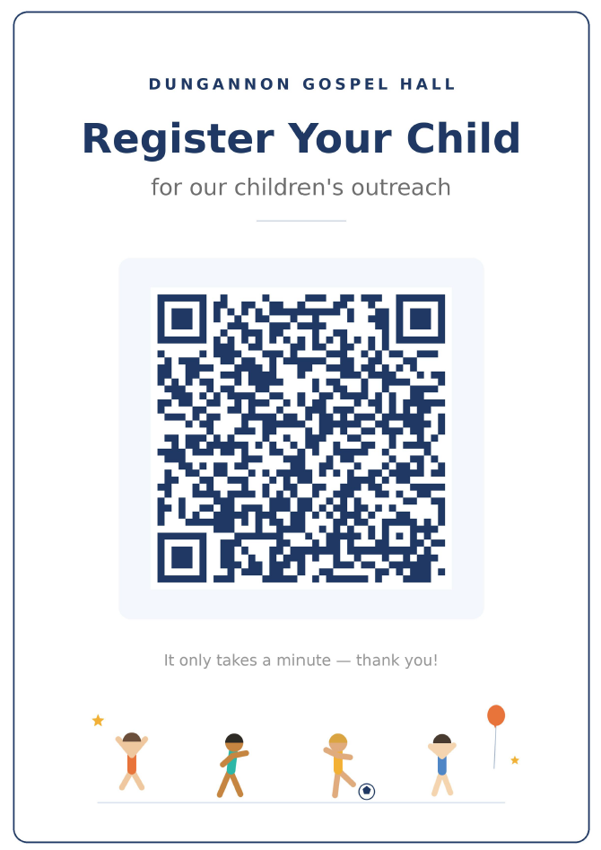

Appendix 2 - Incident report forms
Blank copies of Incident report form kept in the hall at all times.
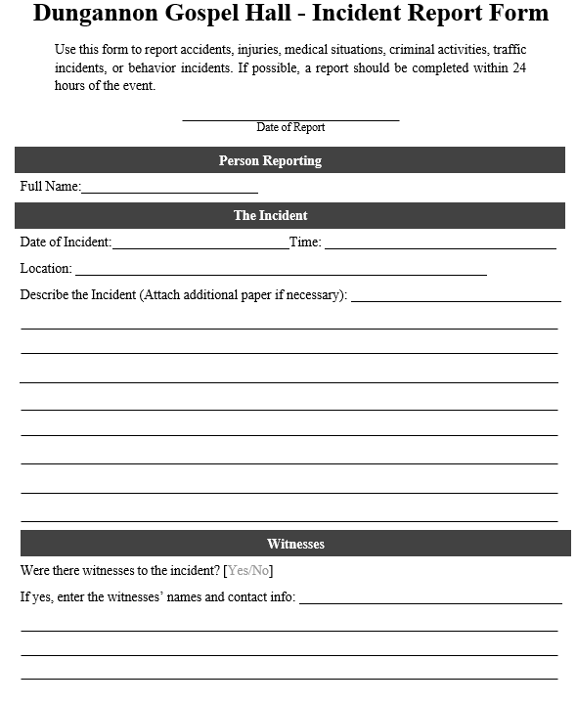

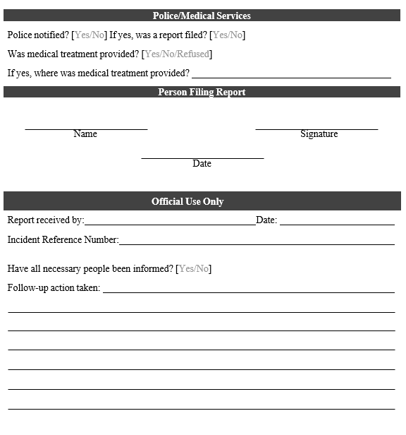

Appendix 3 - Methods & Discipline,

Tips for bus conductors and dealing with bad behaviour

The work of the bus conductor can be summarized as an ability to manage the trip
well. i.e. make the trip as pleasant and enjoyable as possible. This involves managing
children getting on the bus, during the trip and also exiting from the bus.
There are a number of things that can be done that help the conductor with this great
task and there is also discipline to be applied in certain cases.

Things that help manage the trip:
- Try to get to know the parents and let the child see you conversing with their parents.
- Develop a consistent routine that the children know you will not vary from (e.g. always say, "Right - has everyone belted up before we move?" and get the children to say "YES")
- Occupy the children during the trip. This may be getting them to sing or repeat their verses or go over the points they just learned
- Get to know the children by name but don't spend too much time with any one of them.
- Use incentives to control behaviour and promote a quiet trip - like a sweet for
the best behaved on the bus. Or a guessing game where each child is only allowed one guess each. (Games that take a lot of time are good as the trip is over before the child realises it.)
- Try to make the trip enjoyable for the children.

Discipline:
Firm rules that are well known, often repeated and impartial are best. These rules can apply both on transport to and from the hall, but also at the meeting

- Discipline includes verbal warnings, withholding, removing of things, parent
meetings and ultimately banning.
- Have a list of things that are unacceptable and the discipline to be applied.
1st offence - 2nd offence - repeated
- Bad language: Stern Warning - Word with the parents - Ban
- Abuse/Name calling: Stern Warning - Word with the parents - Ban
- Aggression: Word with the parents - Ban
- Bullying: Word with the parents - Ban
- Not wearing seatbelts: Stern Warning - Word with the parents - Ban

- Increase the time ban. i.e. start with 1 week ban, if behaviour repeated 2 weeks ban etc.
- Keep records of all incidents using the incident report form.
Appendix 4 - Code of conduct agreement

Confirmation of receiving Child Protection Policy and training

Please confirm below that you have read and agree to abide by the principles set out in the Child Protection Policy and you understand the conduct that is expected by those organising Children’s work on behalf of Dungannon Gospel Hall

Print Name: _____________________________________

Sign: ___________________________________________

Date: ___________________________________________

Has approval been given for the above person to be involved in the Children’s work linked to Dungannon Gospel Hall: [ YES / NO ]

Print Name: _____________________________________

Sign: ___________________________________________

Date: ___________________________________________

